An advisory commission of the Coastal Protection and Restoration Authority
cOASTAL LOUISIANA LEVEE CONSORTIUM

Amite River Basin Drainage and Water Conservation District

Atchafalaya Basin Levee District

Office of the Governor-Coastal Activities

Chenier Plain Coastal Restoration & Protection Authority

Grand Isle Independent Levee District

Iberia Parish Levee District

Jefferson Davis Parish Government

Lafitte Area Independent Levee District

Lafourche Basin Levee District

Non-Flood Protection Asset Management Authority

North Lafourche Conservation, Levee and Drainage District

Plaquemines Parish Government

Pontchartrain Levee District

The Sewerage and Water Board of New Orleans

South Lafourche Levee District

Southeast Louisiana Flood Protection Authority—East

Southeast Louisiana Flood Protection Authority—West

St. Mary Levee District

St. Tammany Levee District

Terrebonne Levee and Conservation District

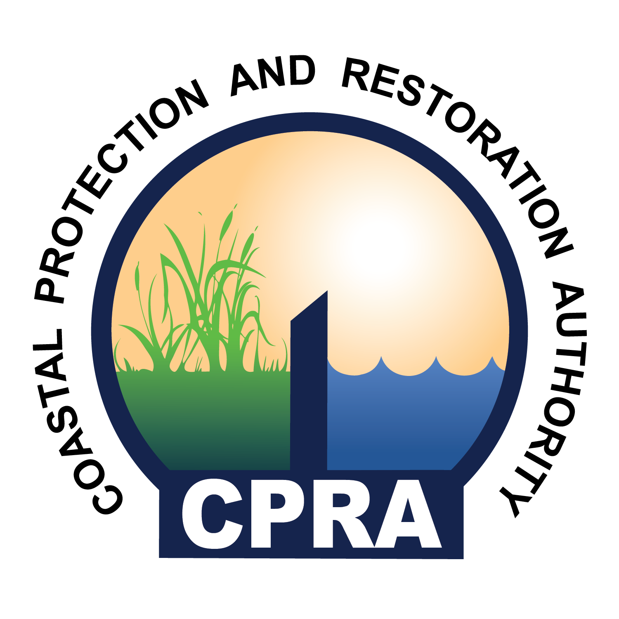

900 North Third St. 4th Floor
Baton Rouge, LA 70802
Coast Louisiana Levee Consortium Meeting
LaSalle Building, GRIFFON ROOM
617 North Third Street
Baton Rouge, LA 70802

Thursday, March 31, 2016
1:30p

- Call to Order – Windell Curole
- Roll Call
- Approval of Agenda
- Introduction of new Chairman of CPRA, John Bradberry
- Approval of Minutes
- Report by Windell Curole
  - Comprehensive Hurricane Protection
  - 408 Permitting
- Report by Dwayne Bourgeois, NLLD
  - NFIP Reform
  - LAMP
  - FFRMS
  - WOTUS
- Report by Nedra Davis, CPCRPA
  - Chenier Plain Authority’s Strategic Plan
- Report by Reggie Dupre, TLCD
  - Discussion of 2016 Regular Legislative Session Issues
- Report by Dietmar Rietschier
  - Comite River Diversion Canal Project
- Public Comment
- Adjourn

